WILD AFRICA FORTUNE TOURS AND TRAVEL

USER’S MANUAL

Contents

1 GENERAL INFORMATION 1

1.1 Website Overview 1

1.2 Organization of the manual 1

2 USING THE WEBSITE 2

2.1 Home Page. 2

2.2 Website Menu 2

2.2.1 Home Link 2

2.2.2 Destinations 2

2.2.3 Trip Packages Link 3

2.2.4 Gallery Link 4

2.2.5 Contact Link. 4

2.3 Home Page Buttons 5

2.3.1 Get Started Button 5

2.3.2 About us Button 5

2.4 Trip Packages Page. 6

# GENERAL INFORMATION

General Information explains in general terms the overview of the website and the purpose for which it is intended.

## Website Overview

Wild Africa fortune Tours and Travel is a basic website that describes the main objective for the organization. It shows the different national parks that can be visited during the tour. The website also describes the different trip packages that can taken by the different visitors. It also shows a summary of activities and places that can be visited included in the trip packages. The website can only be accessed online.

## Organization of the manual

The user’s manual is composed of two sections: General Information and Using the website.

General Information section explains the website and the purpose for which it is intended.

Using the website describes how a user can navigate through the website.

# USING THE WEBSITE

This section describes how a person visiting the website can navigate through and get all information about Wild Africa Fortune Tours and Travel.

## Home Page.

Once the user accesses the link to the website. The home page will be loaded which includes the navigation bar.

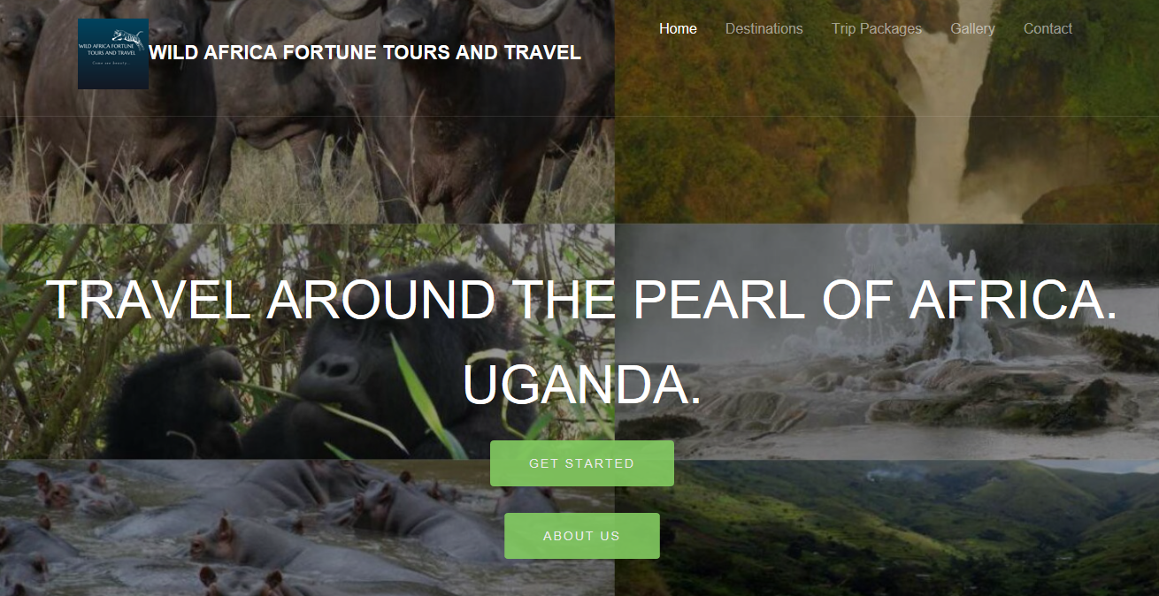

Figure 2. 1: Home page to Wild Africa Fortune Tours and Travel

## Website Menu

The website menu consists of five links and it is the same for all the pages of the website. Four of the links home, gallery, trip packages, contact lead to different pages of the website. The destinations link leads to a section on the home page.

### Home Link

The home link once clicked leads to the homepage of the website which is shown in figure 2.1



Figure 2.1 1: The home link

### Destinations

The destinations link once clicked directs the user to a section on the home page that shows the different national parks that can be visited.



Figure 2.1 2: The destination link.

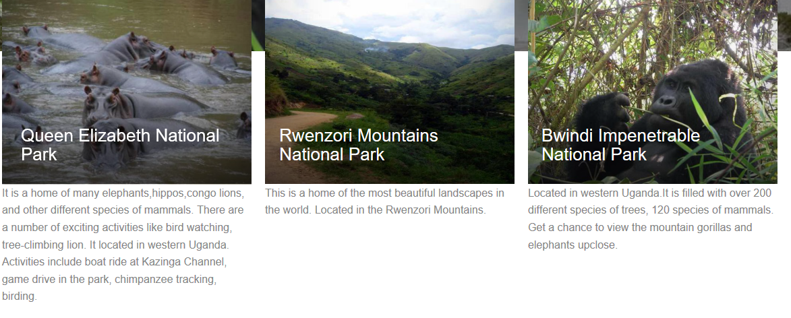

Figure 2.1 3: Part of the information for the destinations section.

### Trip Packages Link

The trip packages link directs the user to a different page that shows the trip packages that are offered by the organization.



Figure 2.1 4: The trip Packages Link.

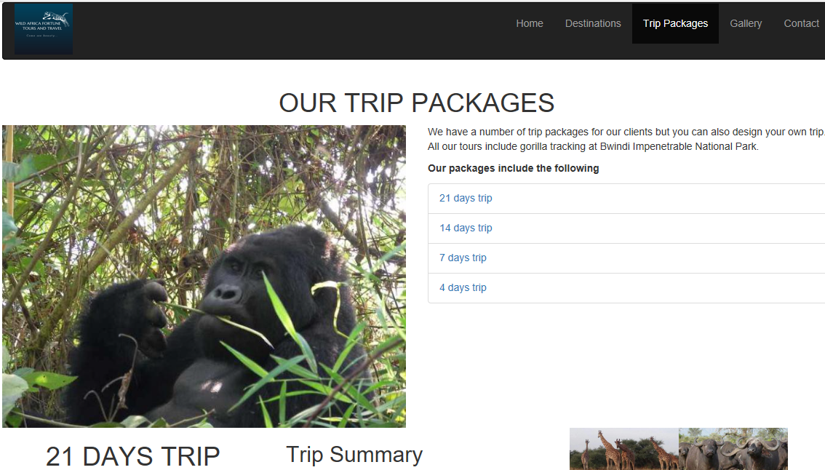

Figure 2.1 5: The trip Packages link that the user is directed to.

### Gallery Link

The Gallery link directs the user to a Gallery page that show the different images for different national parks.



Figure 2.1 6: The Gallery link

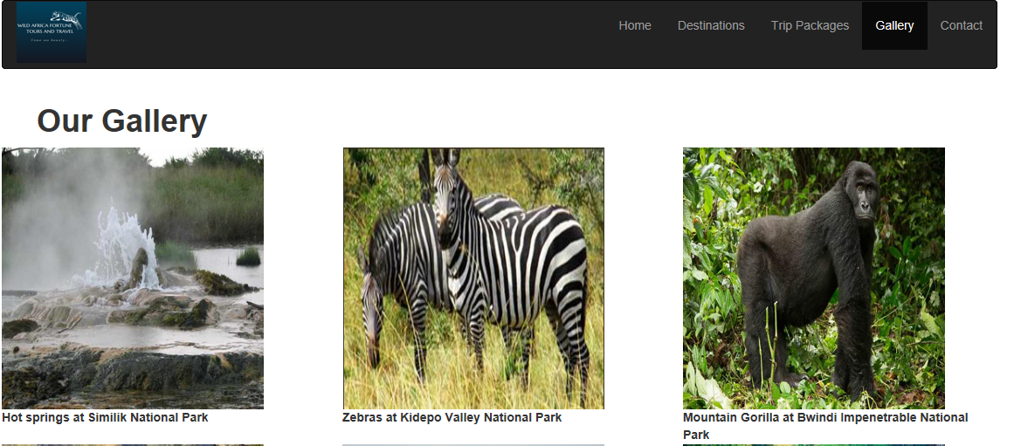

Figure 2.1 7: The Galley page which the user views once the gallery link is clicked.

### Contact Link.

The contact link directs the user to a contact page that has a section that describes the organization as well as contact information that can be used to obtain more information concerning the organization.



Figure 2.1 8: The contact link.

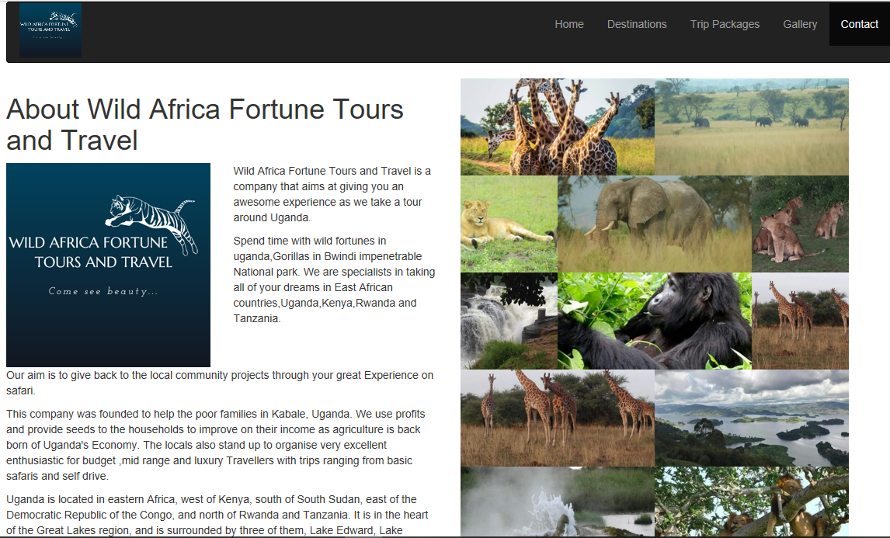

Figure 2.1 9: A section of the contact page.

## Home Page Buttons

The home page two buttons. The Get Started button and About us Button.

### Get Started Button

The Get Started Button directs the user to a section on the home page that shows the national parks that can be visited as shown in Figure 2.1.3.



Figure 2.1 10: The get started button.

### About us Button

The About Us button once clicked leads the user to contact page where he can obtain more information about the organization.

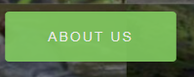

Figure 2.1 11: The about us button.

## Trip Packages Page.

The trip packages page shows the different pages that can be offered by the organization. It also shows a summary of the places that will be visited for each trip package. It contains four links about the packages: 21days trip, 14days trip, 7days trip, 4 days trip.

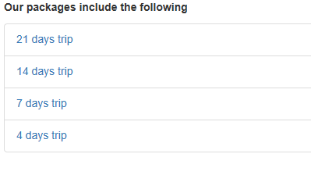

Figure 2.2. 1: The four links for the different trip packages.

Each link directs the user to a section on the trip packages Page that describes the trip package and the summary of places that will be visited.

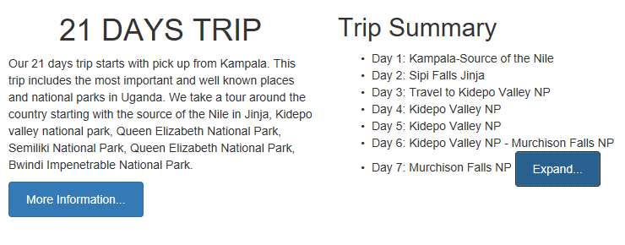

Figure 2.2. 2: Sample of description and trip Summary for the 21 days trip